Lab 1: Problem Discovery and Need Identification
Title
Problem Discovery and Need Identification for Excessive Data and Battery Consumption in Mobile Applications
Lab 1 Report

Name: Selva K Roll No: 24BTCE197

Step 1: Observation
Observation Description
The usage of mobile applications was observed among students and working professionals during daily activities such as social media browsing, online classes, video streaming, and navigation.
Observed Points
- Users keep mobile data and background apps running continuously.
- Battery drains faster even when the phone is idle.
- Apps auto-refresh and sync without user awareness.
- Frequent notifications wake the screen and consume power.
- Poor network signal increases data and battery usage.
Constraints Identified
- Limited battery capacity
- Expensive mobile data plans
- Background processes controlled by apps , not users
Output: Obser
- Frequent charging required (2–3 times/day)
- Unexpected data usage increase
- Phone overheating
- User frustration due to fast battery drain

Step 2: User Identification
User Group | Role | Expectations
Students | Use apps for learning & communication | Long battery life, low data usage
Working Professionals | Use apps for work & meetings | Reliable performance, efficiency
App Developers | Design and maintain apps | High engagement, feature-rich apps
Network Providers | Provide internet services | Stable connectivity, controlled usage
Stakeholder List

Step 3: Interviews / Surveys
Sample Open-Ended Questions
- How often do you experience fast battery drain?
- Which apps consume most data on your phone?
- Do you monitor app data usage regularly?
- How does battery drain affect your daily activities?
- Do you feel apps use data unnecessarily in the background?
- Have you tried any battery/data saving features?
- What frustrates you most about mobile app usage?
Interview Summary
- Interviews conducted with 30 users
- Majority complained about background data usage
- Many users were unaware of which apps consume the most power
- Users felt frustrated when battery drained during emergencies
- Auto-play videos and background syncing were common complaints
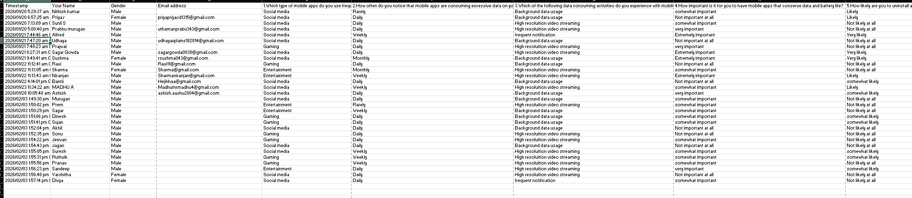

Step 4: Pain-Point Analysis
Pain-Point Table
Pain Point | Category
Fast battery drain | Functional
High mobile data consumption | Functional
Phone overheating | Functional
Anxiety about battery availability | Emotional
Frustration due to frequent charging | Emotional
Lack of user control over background activity | Systemic
Critical Pain Point
➡ Uncontrolled background activity of mobile apps

Step 5: Root Cause Identification (5-Why Analysis)
Problem
Mobile apps consume excessive data and battery.
- Why?
Apps run continuously in the background.
- Why?
Auto-sync, notifications, and updates are enabled.
- Why?
Apps are designed to maximize user engagement.
- Why?
There are limited restrictions enforced by default settings.
- Why?
Users lack awareness and control over app permissions.
Root Causes
- Inefficient app design
- Poor battery optimization
- Default background permissions
- Lack of user awareness

Step 6: Wicked Problem Understanding
Why this is a Wicked Problem
- Difficult to define because data and battery usage vary by user behavior.
- Multiple stakeholders (users, developers, network providers) have conflicting goals.
- Developers want engagement; users want efficiency.
- No single solution works for all apps and users.
Problem Classification
➡ Wicked Problem

Step 7: Reflection
What assumptions were incorrect?
Answer:- Initially, it was assumed that excessive battery drain was mainly caused by poor battery quality or old devices. However, user interviews revealed that uncontrolled background app activity, auto-syncing, notifications, and unnecessary data usage were the major reasons for battery and data drain
• How did user perspectives change your understanding?
Answer:- User perspectives showed that the problem varies based on individual usage patterns, app permissions, and device settings. Many users were unaware of which apps consumed the most battery and data, highlighting that lack of awareness and control plays a significant role in the issue

• Why is jumping to solutions risky?
Answer:- Jumping directly to solutions without understanding user behavior and root causes can result in ineffective fixes. Without proper analysis, solutions may address symptoms rather than underlying issues such as inefficient app design and default background permissions

• What skills did you develop through this lab?
Answer:- This lab helped develop essential skills including:
- Observation of real-world user behavior
- Conducting interviews and surveys
- Empathy towards user frustration
- Root cause analysis using the 5-Why method
- Critical thinking for identifying wicked problems

